**Git Assignment 1 :**

* Creating gitdemo folder
* Changing hostname to gitdemo
* Creating the required three files

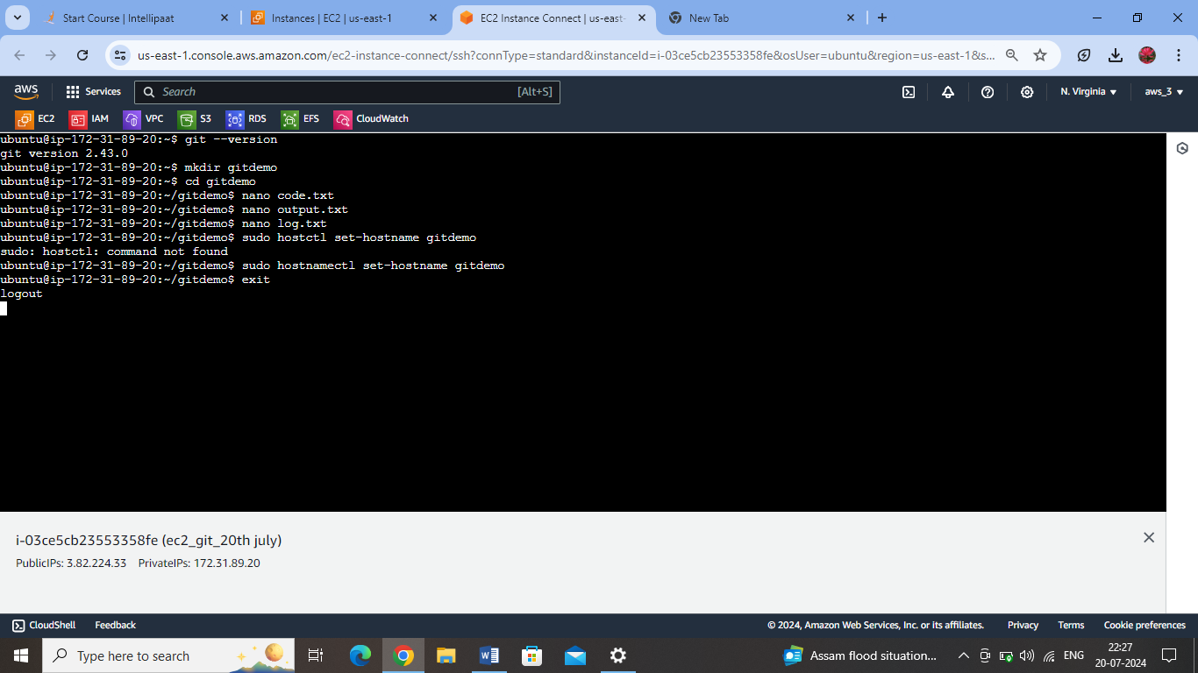

Initialised the git in git demo folder path

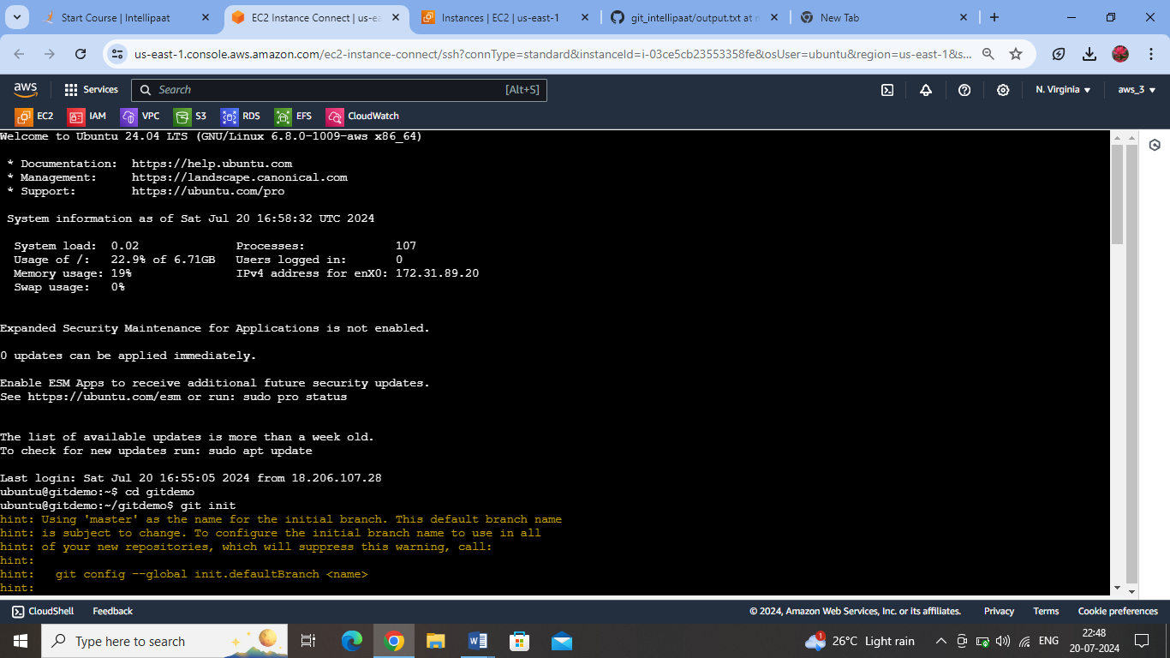

**All three files are in the working directory :**

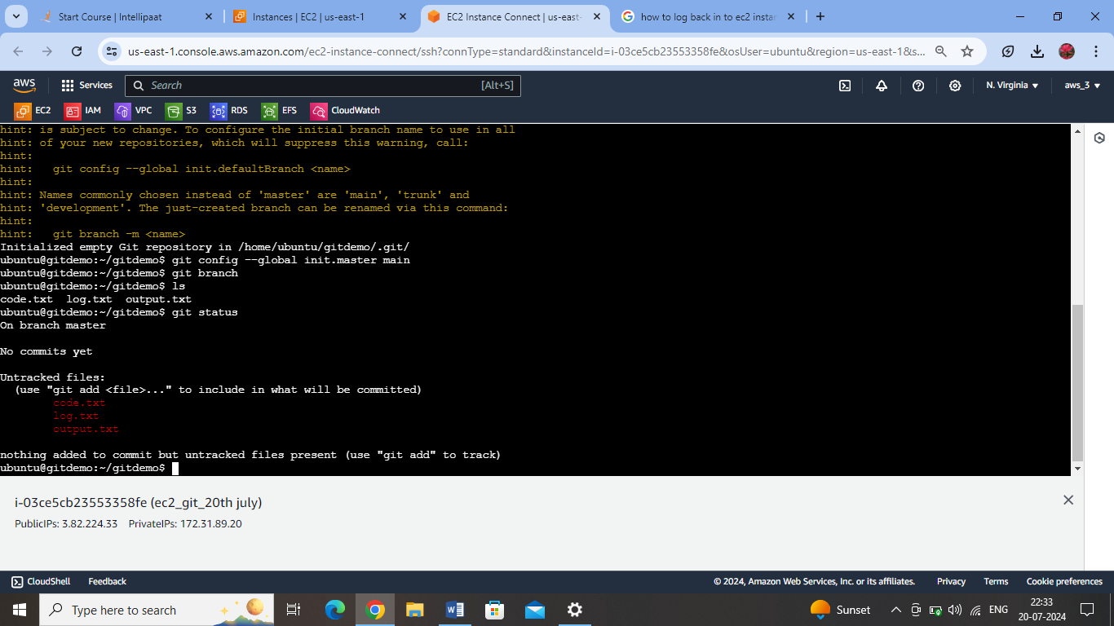

**Moving the output and code files to staging area:**

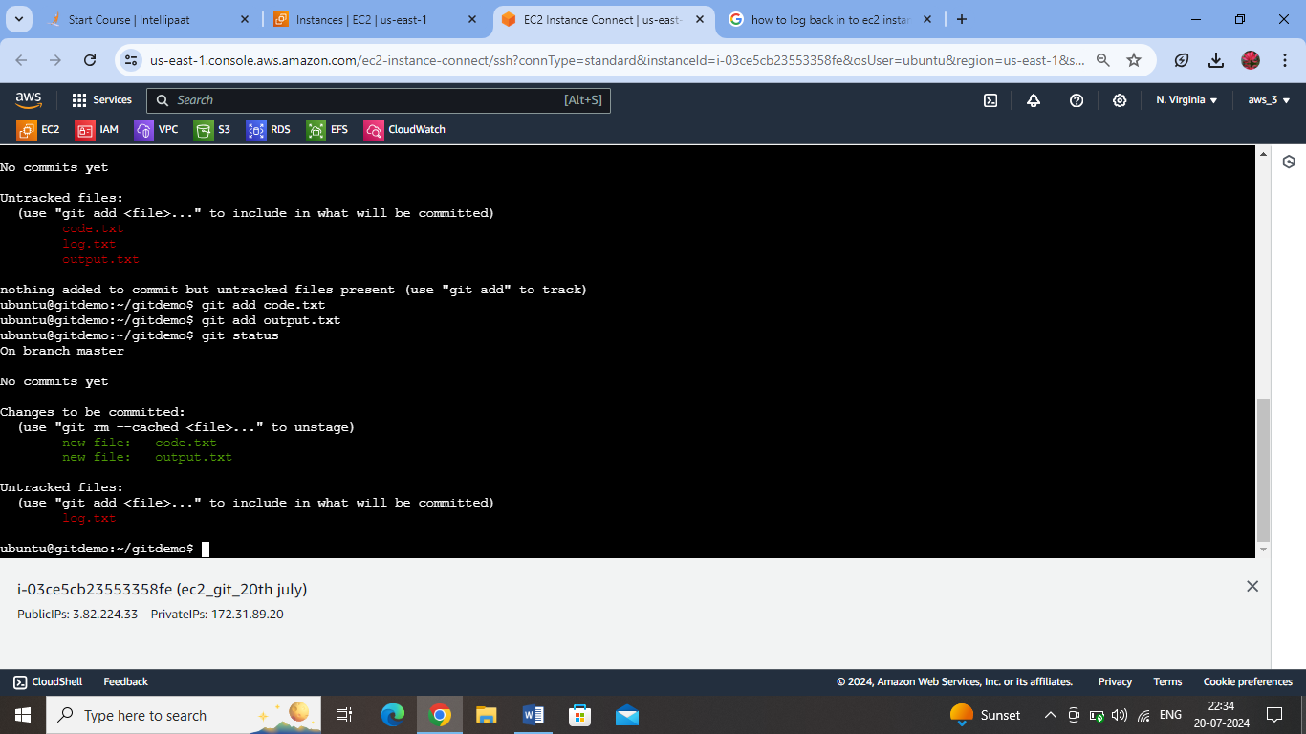

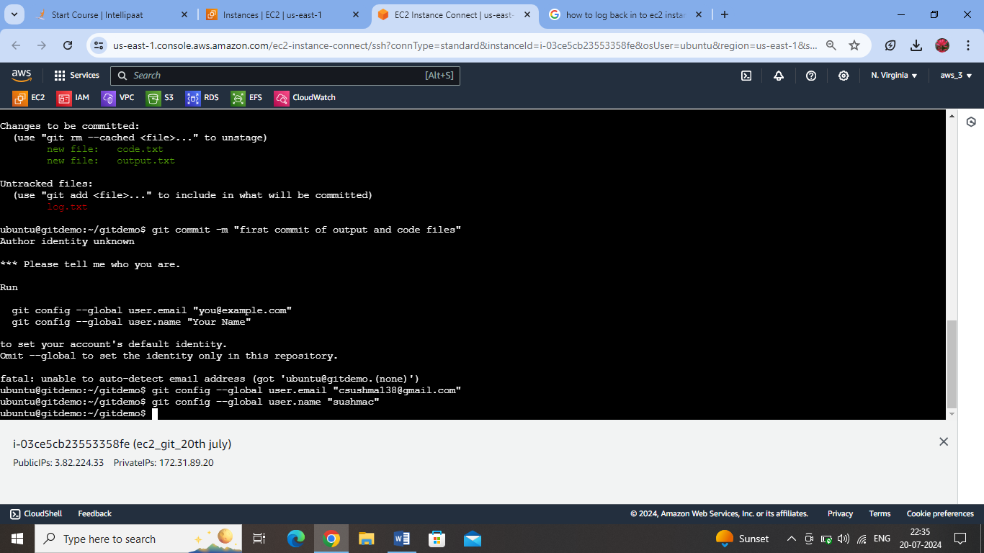

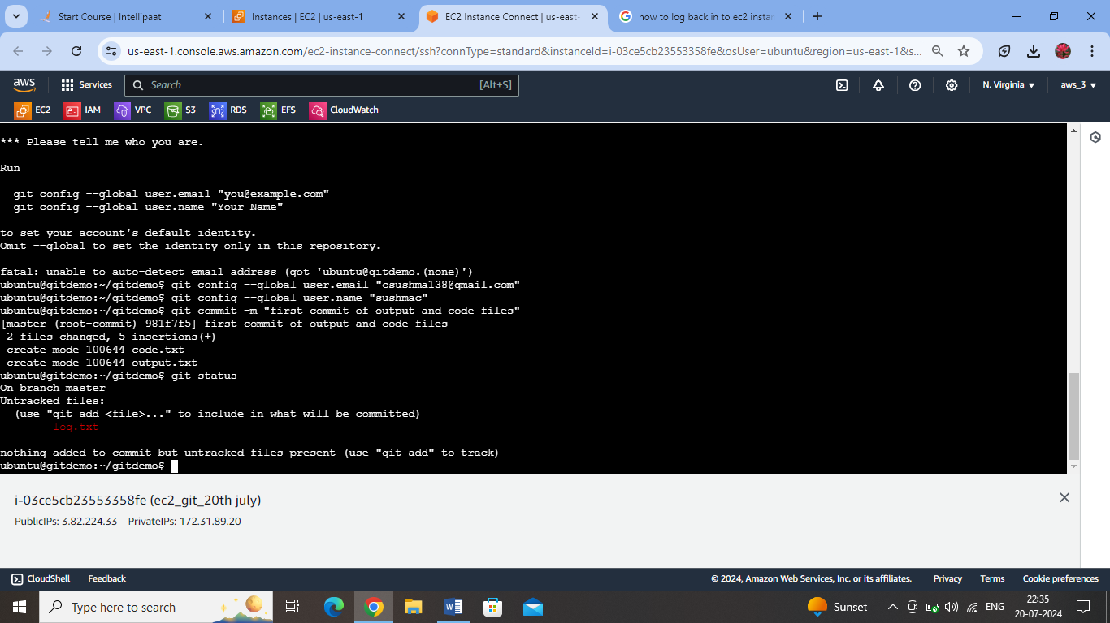

Adding github repo as remote repo and pushing the master branch to it. The committed files alone will be pushed to the branch on github from local repo.

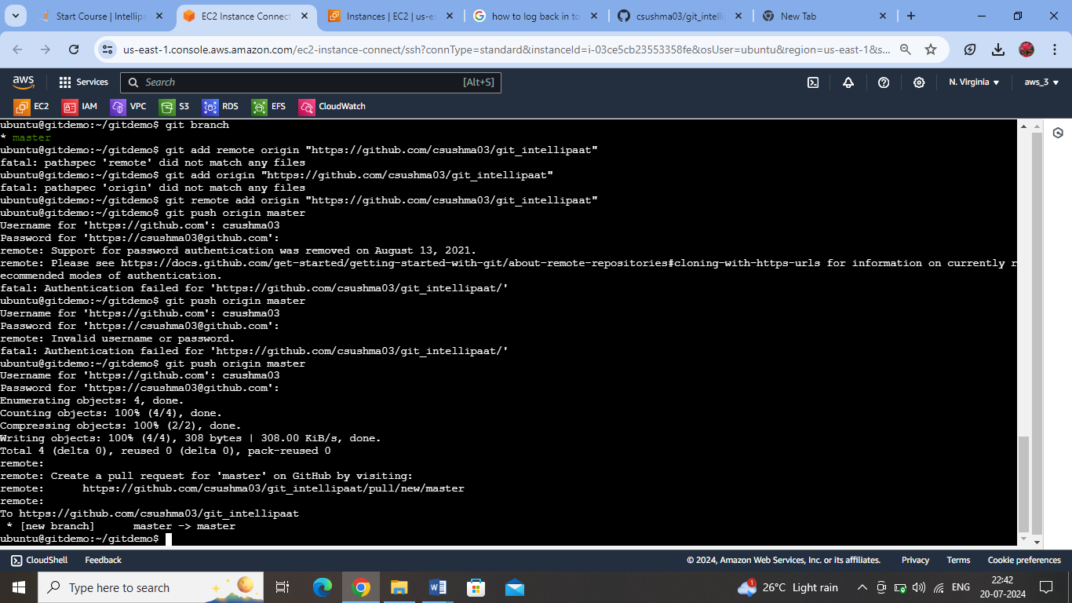

Github reflects the pushed files:

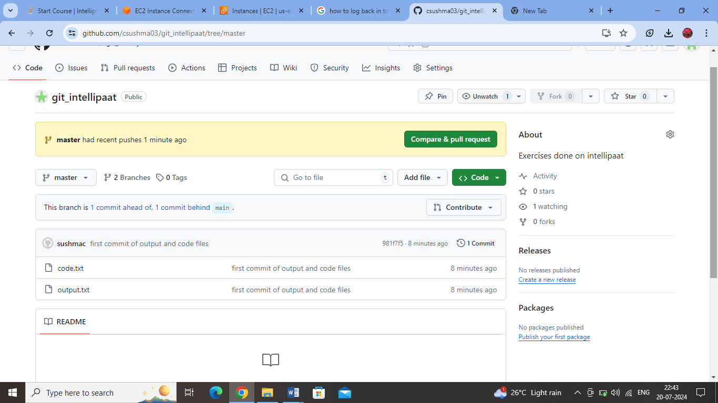

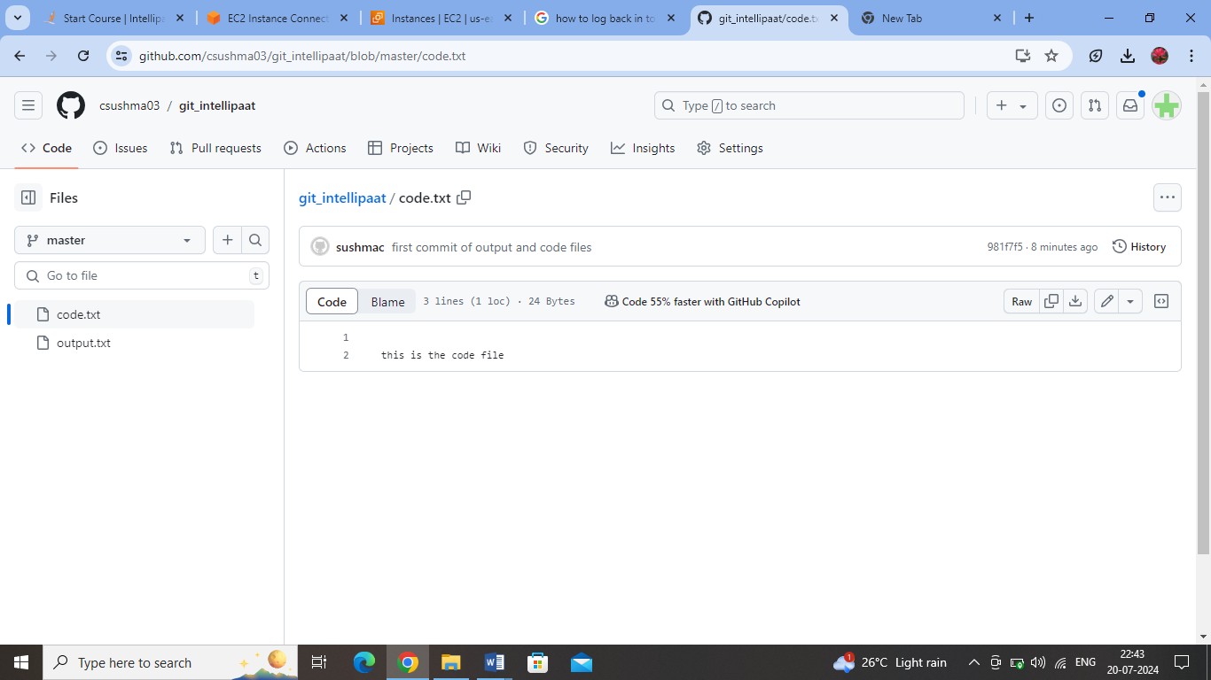

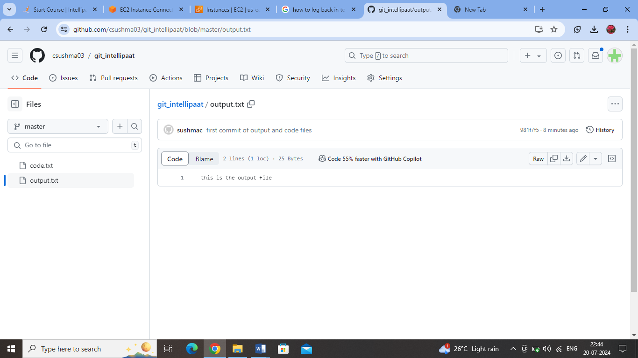

The log.txt file is still in the working area, as we did not stage it or commit it.

